DEPOE BAY RURAL FIRE PROTECTION DISTRICT
BUDGET HEARING
Tuesday, June 13, 2023, at 2pm
Depoe Bay City Hall
570 SE Shell Ave
Depoe Bay - Oregon

***AGENDA***

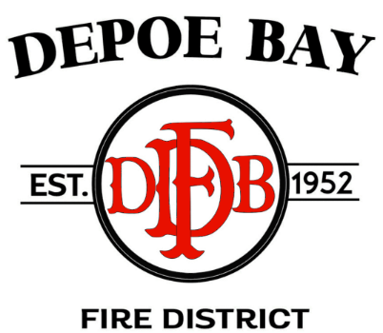

- CALL TO ORDER – Pledge of Allegiance

2. OPEN BUDGET HEARING – 2023-2024 BUDGET

3. ROLL CALL & ESTABLISH QUORUM

4. COMMUNITY INPUT

5. DISCUSSION OF BUDGET

Motion to be heard at Regular Board Meeting

6. ADJOURNMENT

