This is an agreement between Depoe Bay Rural Fire Protection District, an Oregon rural fire protection district (“District”), and the person named below (“Observer”) entered on the date shown.

District has offered Observer the opportunity to ride along with firefighters, incident commanders, EMT’s, and paramedics in emergency vehicles to emergency medical, fire suppression, and hazardous materials (“hazmat”) incidents to observe District response to these incidents. (Observer must be a minimum of 16 years of age.)

Observer for him/herself, and by his/her parent or guardian if Observer is less than 18 years of age, has been informed that riding along in emergency vehicles and observing at the scene of emergency incidents involves a risk of personal and/or bodily injury and property loss. This includes, but is not limited to, the risk of a collision involving the vehicle carrying Observer; the risk of acquiring infectious diseases from persons at the scenes of emergency incidents; the risk of injury from contact with heat, smoke, other toxic chemicals, and hazardous substances at the scenes of fire suppression and hazmat containment; the risk of injury from the activities of emergency personal and equipment operation at the scene of an incident; Observer’s own activities; and similar other risks.

Observer has satisfied him/herself that he/she is in physical and emotional condition that can withstand exposure to these risks. Observer represents to District by his/her signature below that Observer has no physical or emotional condition that makes for probable injury to Observer or others or that may interfere with District employee’s response to the incident. Observer understands and agrees that employees’ attention enroute and at the scene of an emergency incident will be directed primarily to incident response and that Observer must at all times keep a proper lookout and take proper precautions for his/her own safety.

Observer must be appropriately dressed for the fire service work environment. You will be required to wear dark pants (no denim, spandex or sweat pants), sturdy work shoes and a long sleeved shirt.

WAIVER: Therefore, in consideration of District permission that I ride along and observe at the scene of an emergency response, I, for myself, my heirs, executors and assigns hereby WAIVE any claim against District that may occur to me for personal and/or bodily injury and property damage arising out of riding along and observing at the fire station and/or scene of any and all emergency responses by District personnel.

BY SIGNING I REPRESENT THAT I HAVE READ, UNDERSTAND, AND AGREE TO BE BOUND BY THIS AGREEMENT.

Observer Signature: Date:
Print Name:
Address:
If Observer is less than 18 years of age, parent/guardian must sign below:
Parent/Guardian Signature: Date:
Print Name:
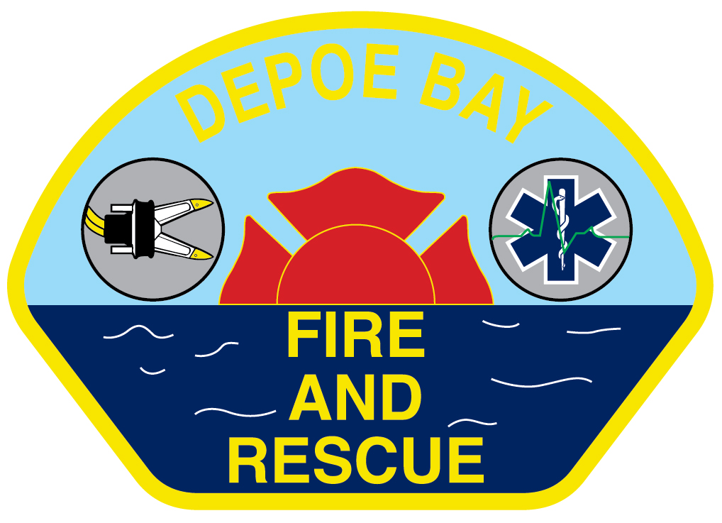
DEPOE BAY RURAL FIRE PROTECTION DISTRICT
P O Box 280 – Gleneden Beach Loop Road – Gleneden Beach, OR 97388 - Telephone (541) 764-2202

RIDE ALONG / OBSERVER STATEMENT OF PURPOSE

I, , wish to make clear my reasons for seeking a ride-along opportunity with Depoe Bay RFPD (DBFD).

I anticipate riding/observing for (i.e. one day, one week, etc.) for the purpose of (i.e. Fire/EMS familiarization, DBFD familiarization, other.)

It is my responsibility to amend this statement if my length of ride-along or intended purpose should change.

I agree to follow all directions given to me by DBFD personnel and supervisors, and I understand that my ride-along may be terminated unilaterally by DBFD at any time.

I understand that information and actions observed during medical incidents are considered protected health information and are confidential. I will not disclose any information observed during confidential medical incidents to any third parties.

Signature Date
(Observer)

Address Phone

Signature Date
(Supervising Officer or Chief)

Upon completion of Ride-Along

Signature Date
(Observer)
Remarks:

Signature Date
(Supervising Officer or Chief)

Send Original Copy to the Administrative Assistant.

