Fact Sheet

OPEN BURNING REGULATIONS

Depoe Bay Fire District’s Open Burning Information Line is 541-765-2208. Always call before you burn for the most up-to-date restrictions on open burning.

Burning regulations are available at the Administrative Office located at Station 2200 in Gleneden Beach or online at depoebayfire.com. You may also request a copy by calling 541-764-2202.

The State of Oregon Department of Environmental Quality Regulations prohibit certain types of burning within the state.

Open burning includes any burning outdoors. A fire in an approved burn barrel with a spark-arrestor screen is open burning. Other examples include burning dry piles of yard debris.

Open burning is allowed between 8:00 a.m. and two hours before sunset on approved burning days. Open burning is generally banned from July 1st through November 1st, and may be banned at any time by the Fire Chief or at the discretion of the Department of Environmental Quality, depending on weather conditions. Remember that all outdoor fires are prohibited during any closed burning season. This may include recreational and warming fires during any stage of a statewide burning ban.

Open burning violations can result in penalties of up to $10,000 per day of violation.

It is against the law to conduct any open burning that:
- Unreasonably interferes with enjoyment of life or property
- Creates a public or private nuisance
- Is a hazard to public safety
- Results in smoke that substantially impairs visibility on a roadway

MATERIAL THAT CANNOT BE BURNED
DEQ regulations prohibit open burning of the following materials at any time, anywhere in Oregon:
- Tires
- Petroleum and petroleum-treated materials
- Asphalt or industrial waste
- Any material that creates dense smoke or noxious odors
- Wet garbage
- Rubber products
- Wire insulation
- Auto bodies
- Dead animals
- Food Service and Industrial Wastes
- Plastic
OPEN BURNING GUIDELINES

- Burn only dry, combustible material.
- Fuel: Natural vegetation consisting of leaves, prunings and other yard and garden refuse.
- Residential yard debris fires shall not exceed 6 feet in diameter and 4 feet in height.
- Fires shall not be built within 25 feet of any buildings, fences, trees or property lines.
- The ground shall be clear of burnable materials for 10 feet outside of fire in all directions
- Fires shall be attended at all times by a responsible person(s).
- Never leave your fire unattended.
- Burn during daylight hours only.
- A garden hose connected to a water supply, or a shovel and 5 gallons of water shall be provided at the burn site at all times.

SAFE BURNING TIPS
- Burn early in the day before the wind comes up.
- Keep adequate fire fighting equipment on hand al all times while burning.
- Never leave your fire unattended.
- Call 541-765-2208 for up-to-date restrictions just prior to burning.
- Maintain a 25-foot distance from buildings and 10-foot fuel breaks from burnable material on the ground.
- Burn during daylight hours only.

If your fire gets out of control, call 911 immediately!

RECREATIONAL/WARMING FIRES
Recreational/Warming fires include the burning of materials other than rubbish where fuel being burned is not contained in an incinerator or other approved container, and with a total fuel area of 3 feet or less in diameter and 2 feet or less in height. Recreational and warming fires shall not be conducted within 25 feet of any structure or combustible material. Maintain a 10-foot fuel break around the fire.

This includes beach fires.

Barbecue pits in open locations shall be constructed of approved noncombustible materials. Barbecue pits outside of buildings shall not be located within 25 feet of combustible walls or roofs or other combustible material.

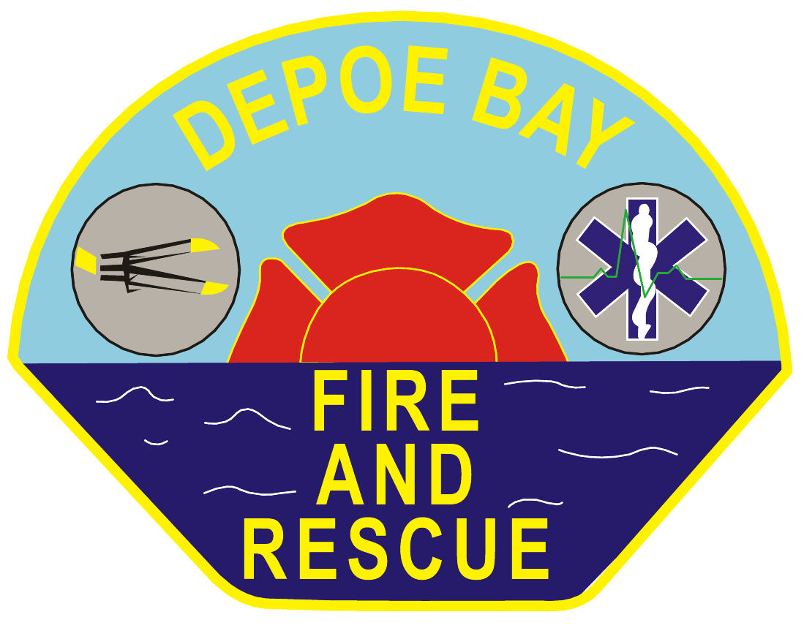

Depoe Bay RFPD
325 SW Hwy 101
Depoe Bay, OR 97341

Administrative Office:
541-764-2202

Outdoor Burning Information:
541-765-2208
or
www.depoebayfire.com

State of Oregon Department of Environmental Quality’s Oregon Administrative Rule 340-264-0100 (3)(a) states that commercial open burning is prohibited within Lincoln County except as provided in OAR 340-264-0180.

Department of Environmental Quality Definitions:

Commercial Open Burning means the open burning of any commercial waste. Examples of commercial waste are waste material from offices, wholesale or retail yards and outlets, warehouses, restaurants, mobile home parks, domestic waste removed from the property of origin, and dwellings containing more than four family living units, such as apartments, condominiums, hotels, motels or dormitories.

Construction Open Burning means the burning of any construction waste.

Construction Waste means any waste material generally used for, resulting from or produced by a building or construction project. Examples of construction waste are wood, lumber, paper, crating and packing materials processed for or used during cleanup of a constructed site.

Demolition Open Burning means the open burning of demolition waste.

Demolition Waste means any material resulting from or produced by the complete or partial destruction or tearing down of any man-made structure, or the clearing of any site for land improvement or cleanup, excluding yard debris (domestic waste) and agricultural waste.

Land Clearing means the removal of trees, brush, logs, stump debris or man-made structures for the purpose of site clean up or site preparation. All waste material generated by land clearing is demolition waste except those materials included in the definitions of agricultural wastes, yard debris (domestic waste) and slash.

OAR 340-264-0180 – Letter Permits

- Open burning of commercial, industrial, slash, construction or demolition waste on a single occurring or infrequent basis or the open burning of yard debris that is otherwise prohibited, may be permitted by a letter permit issued by the Department in accordance with this rule and subject to OAR 340-264-0050, 340-264-0060 and 340-264-0070, and the requirements and prohibitions of local jurisdictions and the State Fire Marshal. OAR 340-014-0025 and division 216 do not apply.
- A letter permit may only be issued on the basis of a written application for disposal of material by burning that has been approved by the Department. Each application for a letter permit must contain the following items:
  - The quantity and type of material proposed to be burned;
  - A listing of all alternative disposal methods and potential costs that have been identified or investigated;
  - The expected amount of time that will be required to complete the burning (not required for yard debris);
  - The methods proposed to be used to insure complete and efficient combustion of the material;
  - The location of the proposed burning site;
  - A diagram showing the proposed burning site and the structures and facilities inhabited or used in the vicinity including distances thereto;
  - The expected frequency of the need to dispose of similar materials by burning in the future;
  - If the application is for prescribed burning of standing vegetation for the purpose of creating or restoring wetlands or for promoting or enhancing habitat for indigenous species of plants or animals, the application must also include a citation to the federal or state law or program requiring or authorizing such conversion or enhancement. The application must also include a statement from the appropriate agency responsible for implementing the law or program that open burning is the most practicable alternative for the conversion or enhancement.
  - Any other information that the applicant considers relevant or the Department may require.

