DEPOE BAY RURAL FIRE PROTECTION DISTRICT
BOARD OF DIRECTORS
SPECIAL BUDGET WORKSHOP
Tuesday, April 18, 2023
2 PM
Depoe Bay City Hall
235 SE Shell Ave. Depoe Bay, OR

***AGENDA***

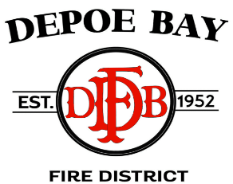

CALL TO ORDER – Pledge of Allegiance

ROLL CALL

BUDGET WORKSHOP

PUBLIC COMMENT/AGENDA SUGGESTIONS – OPEN

ADJOURN

Next scheduled meeting: Budget Committee Meeting and Regular Board Meeting
Tuesday, May 9th, 2023 – 10AM
Depoe Bay City Hall – 235 Shell Ave. Depoe Bay, OR

Depoe Bay Fire District - Board of Directors Meeting
Please join my meeting from your computer, tablet or smartphone.
https://global.gotomeeting.com/join/833057797
You can also dial in using your phone.
United States: +1 (872) 240-3311
Access Code: 833-057-797
New to GoToMeeting? Get the app now and be ready when your first meeting starts: https://global.gotomeeting.com/install/833057797

